Lecture. Druqs,affecting CNS. Phatrmacology of general anesthetics, etanol and hypnotics.

Drugs that act in the Central Nervous System.
- General Anesthetics
- Hypnotics
- The Alcohols

NEUROTANSMITTERS OF CENTRAL NERVOUS SISTEM
1. AMINO ACIDS
QABA (A,B), GLYCINE – inhibitory transmitter
glutamate, aspartate- excitative transmitters

2. ACETYLCHOLINE - neostriatum, medial septal nucleus, reticular formation (cognitive functions, Alzheimers disease-age-related dementia)

3. MONOAMINES

NOREPINEFRUNE – brain stem, locus ceruleus, lateral area of reticular formation (behavioral reactions - attention, wakefulness)
DOPAMINE- limbic structures-nucleus accumbens (pleasure sentence, drug dependens)
SEROTONINE- brain stem (depression)
NEUROPEPTIDES-(Substance P, enkephalins,, endorphins)
NITRIC OXIDE

GENERAL ANESTHETICS
General anesthesia is essential to surgical practice because it cause patients analgesic, amnesic, unconscious, muscle relaxation and suppression of undesirable reflexes.

Orders to general anesthetics
- Anesthesia would be smoothly and rapidly
- Wide margin of safety
- Sufficient anesthetica depth
- Lightly controlled anesthesia
- Absent of side effects
- Non-flammabily
- Absent of excitement stage
MECHANISM OF ACTION
- Reversible inhibition of synaptic transmission in CNS
- Disturbance between CORTEX and SUBCORTEX

TYPES OF GENERAL ANAESTHETICS
INHALATIONAL AGENTS
Volatile liquids:
Halotane, Enflurane, Isoflurane, Methoxyflurane,
Ether, Chlorethyle, Trichlorethylen

Qaseous drugs:
Nitrous oxide, Cyclopropane

INTRAVENOUS AGENTS
Barbiturates:
Hexenal, Thiopental
Benzodiazepines and other induction agents:
Ketamine, Proranidide, Sodium-oxybutiras, Predione, Etomidate, Midazolam

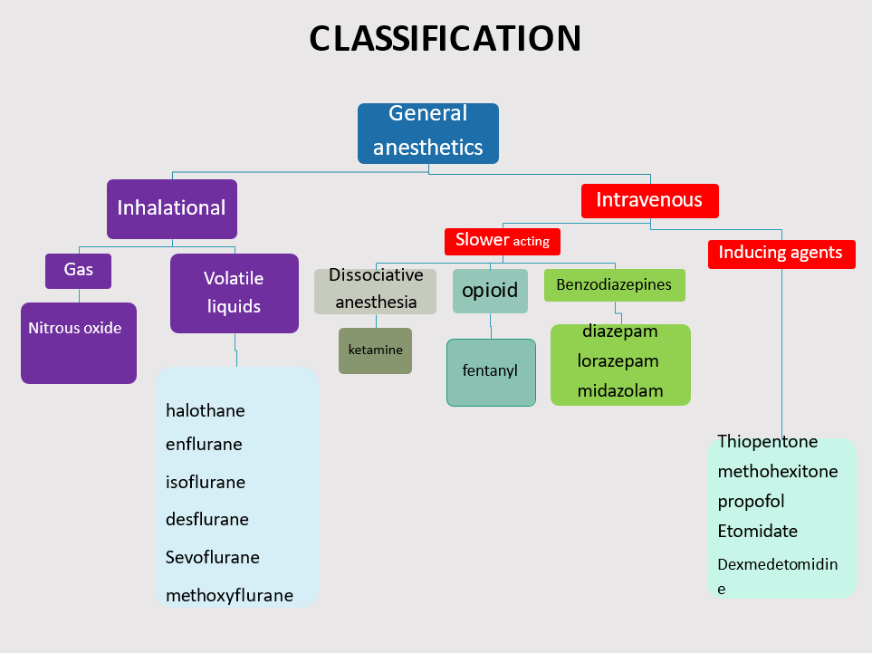

General Anesthesia
General anesthesia is a reversible state of CNS depression, causing loss of response to and perception of stimuli.
For patients undergoing surgical or medical procedures, anesthesia provides five important benefits:
- Sedation and reduced anxiety
- Lack of awareness and amnesia
- Skeletal muscle relaxation
- Suppression of undesirable reflexes
- Analgesia

Because no single agent provides all desirable properties both rapidly and safely, several categories of drugs are combined (I.V and inhaled anesthesia and preanesthetic medications) to produce optimal anesthesia known as a Balanced anesthesia.

Patient factors in selection of anesthesia
Drugs are chosen to provide safe and efficient anesthesia based on:
- The type of the surgical or diagnostic procedure
- Patient characteristics such as organ function, medical conditions, and concurrent medications. e.g., HTN, bronchial asthma.

Status of organ systems
Respiratory system:
All inhaled anesthetics depress the respiratory system.
They are bronchodilators.
Liver and kidney:
The release of fluoride, bromide, and other metabolic products of the halogenated hydrocarbons can affect these organs, especially with repeated anesthetic administration over a short period of time.
Pregnancy:
Effects on fetal organogenesis are a major concern in early pregnancy.
1.Nitrous oxide can cause aplastic anemia in the unborn child. Oral clefts have occurred in the fetuses of women who have received benzodiazepines.
2.Diazepam should not be used routinely during labor, because it results in temporary hypotonia and altered thermoregulation in the newborn.

Status of organ systems:
Nervous system:
- The existence of neurologic disorders (e.g., epilepsy or myasthenia gravis) influences the selection of anesthetic.
- A patient history of a genetically determined sensitivity to halogenated hydrocarbon-induced malignant hyperthermia “an autosomal dominant genetic disorder of skeletal muscle” that occurs in susceptible individuals undergoing general anesthesia with volatile agents and muscle relaxants (eg, succinylcholine).
- The malignant hyperthermia syndrome consists of the rapid onset of tachycardia and hypertension, severe muscle rigidity,
hyperthermia.
- Rx Dantroline

Preanesthetic Medications
Preanesthetic medications serve to
- calm the patient, relieve pain,
- protect against undesirable effects of the subsequently administered anesthetics or the surgical procedure.
- facilitate smooth induction of anesthesia,
- lowered the required dose of anesthetic
Preanesthetic Medicine:
- Benzodiazepines; midazolam or diazepam: Anxiolysis & amnesia.
- Diphenhydramine: Prevention of allergic reactions: antihistamines
- H2 receptor blocker- famotidine, ranitidine: Reduce gastric acidity.

Preanesthetic medications:
- Antiemetics- ondansetron: Prevents aspiration of stomach contents and post surgical vomiting:
- Acetaminophen or opioids (fentanyl) for analgesia ➢Anticholinergics: (glycopyrrolate, scopolamine):
- Reduce bronchial and salivary secretion: irritant inhaled anesthetic cause excessive salivation and secretion.

Concomitant use of other drugs
Patients may take medications for underlying diseases or abuse drugs that alter response to anesthetics. For example, alcoholics have elevated levels of liver enzymes that metabolize anesthetics, and drug abusers may be tolerant to opioids.

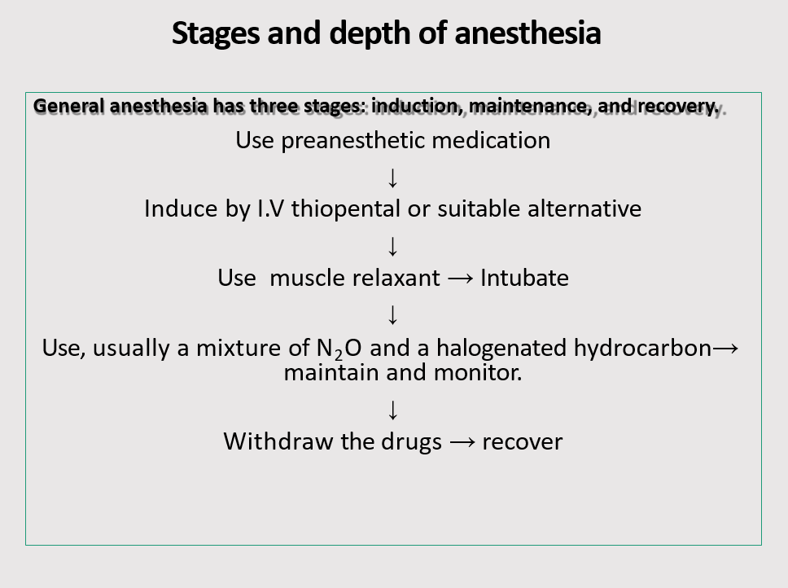

Stages and depth of anesthesia/ Induction
Induction: The period of time from the onset of administration of the anesthetic to the development of effective surgical anesthesia in the patient. It depends on how fast effective concentrations of the anesthetic drug reach the brain.
Thus GA is normally induced with an I.V thiopental, which produces unconsciousness within 25 seconds or propofol producing unconsciousness in 30 to 40 seconds after injection.
At that time, additional inhalation or IV drugs may be given to produce the desired depth of surgical stage III anesthesia. This often includes an IV neuromuscular blocker such as rocuronium, vecuronium, or succinylcholine to facilitate tracheal intubation and muscle relaxation.
Inhalation induction: For children without IV access, non pungent agents, such as halothane or sevoflurane, are used to induce GA.

Stages and depth of anesthesia/ Maintenance
Maintenance: After administering the anesthetic, vital signs and response to stimuli are monitored continuously to balance the amount of drug inhaled and/or infused with the depth of anesthesia.

Maintenance is commonly provided with volatile anesthetics, which offer good control over the depth of anesthesia.
Opioids such as fentanyl are used for analgesia along with inhalation agents, because the latter are not good analgesics.

STAGES OF ANESTHESIA
1. STAGE OF ANALGESIA (loss of sensitivity, patient on conscens)
2. STAGE OF EXCITEMENT (activation of subcortex)
- Loss of consciousness
- Cough reflex, bronchospasm, vomiting, glands secretion
- Bradycardia,cardiac arrest
- Speech excitation
- Motor stimulation
- Rise tone of skeletal muscles
3. STAGE OF SURGICAL ANESTHESIA (pulce, breathing, pressure are normal, muscles are relax)
- Surface narcosis
- Light narcosis
- Deep narcosis
- Ultra deep narcosis
- (planes describes in term of: changes in ocular movements, eyes reflexes, pupil size. Planes show the rate of depth of anesthesia)
4. RECOVERY. (STAGE OF MEDULLARY DEPRESSION
(Depression of vasomotor and respirator centers in the medulla-death)
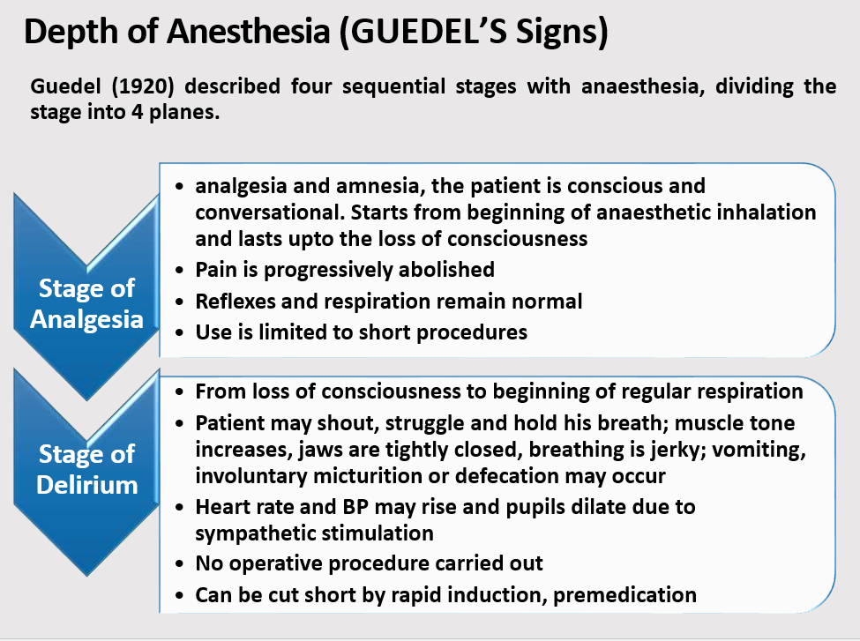
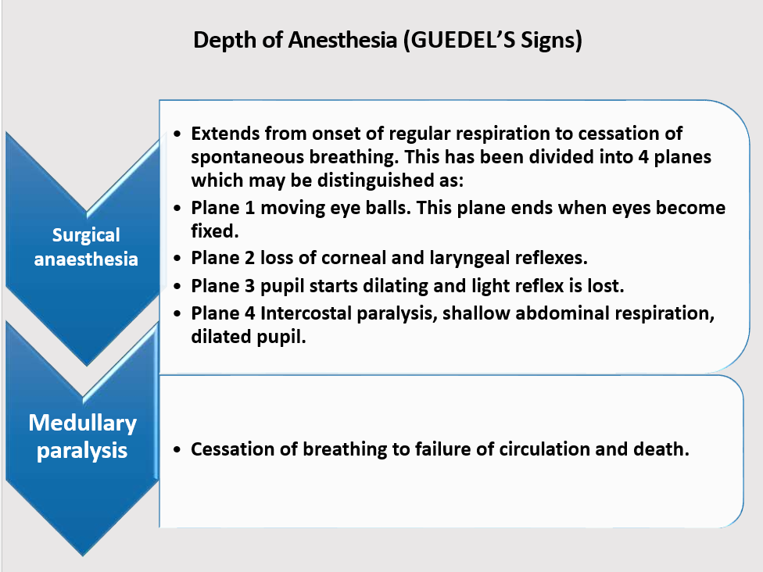

Inhalation anesthetics
Inhaled gases are used primarily for maintenance of anesthesia. Depth of anesthesia can be rapidly altered by changing the inhaled concentration.
Common features of inhaled anesthetics
Modern inhalation anesthetics are nonflammable, nonexplosive agents.
Decrease cerebrovascular resistance, resulting in increased perfusion of the brain
Cause bronchodilation, and decrease both spontaneous ventilation and hypoxic pulmonary vasoconstriction (increased pulmonary vascular resistance in poorly aerated regions of the lungs, redirecting blood flow to more oxygenated regions).
Movement of these agents from the lungs to various body compartments depends upon their solubility in blood and tissues, as well as on blood flow. These factors play a role in induction and recovery.

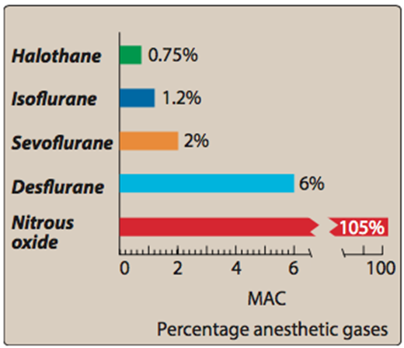
MAC (potency)
MAC (potency): the minimum alveolar concentration, the endtidal concentration of inhaled anesthetic needed to eliminate movement in 50% of patients stimulated by a standardized incision.
- MAC is the ED50 of the anesthetic.
- the inverse of MAC is an index of potency of the anesthetic.

MAC expressed as the percentage of gas in a mixture required to achieve the effect.
Numerically, MAC is small for potent anesthetics such as sevoflurane and large for less potent agents such as nitrous oxide.

Factors Determine the time course for attaining Steady State:
Solubility in the blood: called the blood/gas partition coefficient.
The solubility in blood is ranked in the following order:
halothane>enflurane>isoflurane>sevoflurane>desflurane>N₂O.
An inhalational anesthetic agent with low solubility in blood shows fast induction and also recovery time (e.g., N₂O), and an agent with relatively high solubility in blood shows slower induction and recovery time (e.g., halothane).

Factors Determine the time course for attaining Steady State:
Effect of different tissue types on anesthetic uptake:
It is also directly proportional to the capacity of that tissue to store anesthetic (a larger capacity results in a longer time required to achieve steady state).
Capacity, in turn, is directly proportional to the tissue’s volume and the tissue/ blood solubility coefficient of the anesthetic.

Factors Determine the time course for attaining Steady State:
Four major tissue compartments determine the time course of anesthetic uptake:
- Brain, heart, liver, kidney, and endocrine glands: these highly perfused tissues rapidly attain a steady-state with the PP of anesthetic in the blood.
- Skeletal muscles: poorly perfused, and have a large volume, prolong the time required to achieve steady-state.
- Fat: poorly perfused. However, potent GA are very lipid soluble. Therefore, fat has a large capacity to store anesthetic. This combination of slow delivery to a high capacity compartment prolongs the time required to achieve steady-state.
- Bone, ligaments, and cartilage: these are poorly perfused and have a relatively low capacity to store anesthetic.

MECHANISM OF ACTION OF ANAESTHESIA

No specific receptor has been identified. The fact that chemically unrelated compounds produce anesthesia argues against the existence of a single receptor.
The focus is NOW on proteins comprising ion channels:
- GABAA receptors, Glycine receptors,
- NMDA glutamate receptors (nitrous oxide and ketamine ):
- Nicotinic receptors: Blocks the excitatory postsynaptic current of the nicotinic receptors.

Currently, there are 5 inhalational and 5 intravenous anesthetics used to induce or maintain general anesthesia: Inhalational:
Nitrous Oxide, Isoflurane, Sevoflurane, Desflurane and Xenon. Intravenous: Propofol, Etomidate, Ketamine, Methohexital and Thiopental. These 10 general anesthetic drugs are often accompanied by sedative benzodiazepines: midazolam, diazepam and lorazepam.
Of these 10 general anesthetics:
ketamine, nitrous oxide and xenon inhibit ionotropic glutamate receptors, with the strongest effects being seen on the NMDA receptor subtype. These anesthetics also have modest effects on many other receptors, including GABAARs, but their primary action is the blockade of NMDA receptors.
The other 7 general anesthetics and 3 sedatives share a common target and mechanism of action, they all enhance the function of GABAARs, the most abundant fast inhibitory neurotransmitter receptor in the CNS. These 7 general anesthetics also have a spectrum of modest to strong effects on other ion channels, including glycine receptors, neuronal nicotinic receptors, 5-HT3 receptors, glutamate receptors and the potassium channels.
Mechanisms underlying the anesthetic effect are not properly known yet.

Halothane (Prototype)
Advantages:
- Potent anesthetic, rapid induction & recovery
- Neither flammable nor explosive, sweet smell, non irritant
- Does not augment bronchial and salivary secretions.
- Low incidence of post operative nausea and vomiting.
- Relaxes both skeletal and uterine muscle, and can be used in obstetrics when uterine relaxation is indicated.
- Combined with its pleasant odor, this makes it suitable in children for inhalation induction.

Halothane
Disadvantages:
- Weak analgesic (thus is usually coadministerd with N₂O, opioids)
- Is a strong respiratory depressant
- Is a strong cardiovascular depressant; halothane is vagomimetic and cause atropine-sensitive bradycardia.
- Hepatotoxic: is oxidatively metabolized in the liver to tissue- toxic hydrocarbons (e.g., trifluroethanol and bromide ion).
- Malignant hyperthermia

Enflurane
Advantages:
- Less potent than halothane, but produces rapid induction and
- recovery
- ~2% metabolized to fluoride ion, which is excreted by the kidney
- Has some analgesic activity

Disadvantages: CNS excitation at twice the MAC, Can induce seizure

Desflurane:
- Rapidity of induction and recovery: outpatient surgery
- Less volatility (must be delivered using a special vaporizer)
- It decreases vascular resistance and perfuse all major tissues very well.
- Irritating cause apnea, laryngospasm, coughing, and excessive secretions
Sevoflurane:
- Has low pungency, not irritating the airway during induction; making it suitable for induction in children
- Rapid onset and recovery:
- Metabolized by liver, releasing fluoride ions; thus, like enflurane, it
may prove to be nephrotoxic.
Methoxyflurane
- The most potent and the best analgesic anesthetic available for clinical use. Nephrotoxic and thus seldom used.

Nitrous oxide (N₂O)
- It is a potent analgesic but a weak general anesthetic.
- Rapid onset and recovery:
- Does not depress respiration, and no muscle relaxation.
- Clinical use: dental surgery, obstetrics, postoperative physiotherapy, refractory pain in terminal illness, and maintenance of anesthesia.
- The least hepatotoxic, Teratogenic, bone marrow depression.

INTRAVENOUS ANESTHETICS
- Short-duration acted (duration of narcosis 15 min)
- PROPANIDIDE, KETAMIME, PROPOFOLE
- Intermediate duration acted (25min)
- THIOPENTAL-SODIUM, PREDION, HEXENAL
- Long duration acted (60 min and more)
- SODIUM-OXYBUTIRATE

Intravenous anesthetics
Barbiturates (thiopental, methohexital)
- Potent anesthetic but a weak analgesic
- High lipid solubility; quickly enter the CNS and depress function, often in less than one minute, and redistribution occur very rapidly as well to other body tissues, including skeletal muscle and ultimately adipose tissue (serve as a reservoir).
- All barbiturates can cause apnea, coughing, chest wall spasm, laryngospasm, and bronchospasm

Intravenous anesthetics/ Propofol
Propofol, Phenol derivative, It is an IV sedative-hypnotic used in the induction and or maintenance of anesthesia.

- Onset is smooth and rapid (40 seconds)
- Decrease BP without depressing the myocardium, it also reduce intracranial pressure.
- It is widely used and has replaced thiopental as the first choice for anesthesia induction and sedation, because it produces a euphoric feeling in the patient and does not cause post anesthetic nausea and vomiting.
- Poor analgesia.

Intravenous anesthetics/ ketamine
- Ketamine (phencyclidine derivative) a short-acting, anesthetic, induces a dissociated state in which the patient is unconscious (but may appear to be awake) and does not feel pain.
- This dissociative anesthesia provides sedation, amnesia, and immobility.
- Ketamine is also a potent bronchodilator.
- Therefore, it is beneficial in patients in asthmatics. Conversely, it is contraindicated in hypertensive or stroke patients.
- Ketamine is used mainly in children and elderly adults for short procedures.
- It is not widely used, because it increases cerebral blood flow and may induce hallucinations, particularly in young adults.

Adjuvants/ BDZs & Opioids (fentanyl, sufentanil)
Benzodiazepine (midazolam, lorazepam and diazepam) Are used
in conjunction with anesthetics to sedate the patient.

Opioids:
- Analgesic, not good amnesic, used together with anesthetics.
- They are administered either I.V, epidurally, or intrathecally

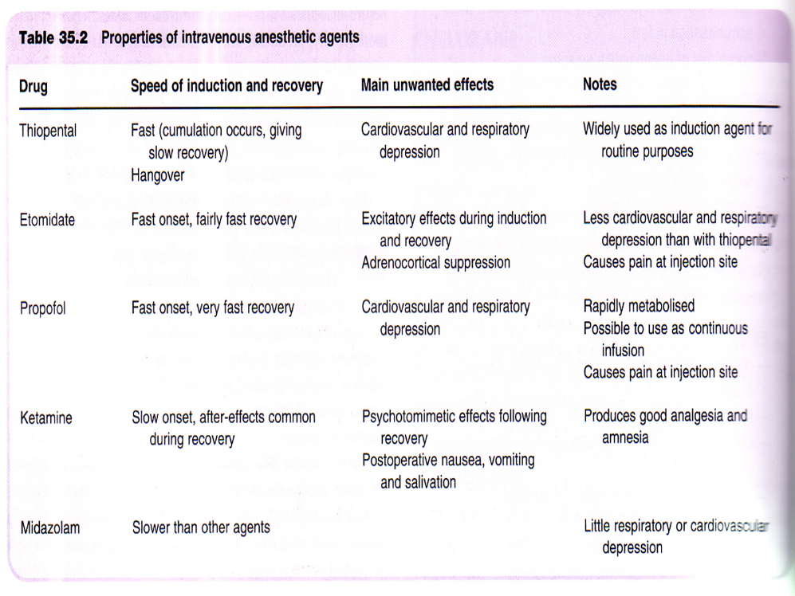

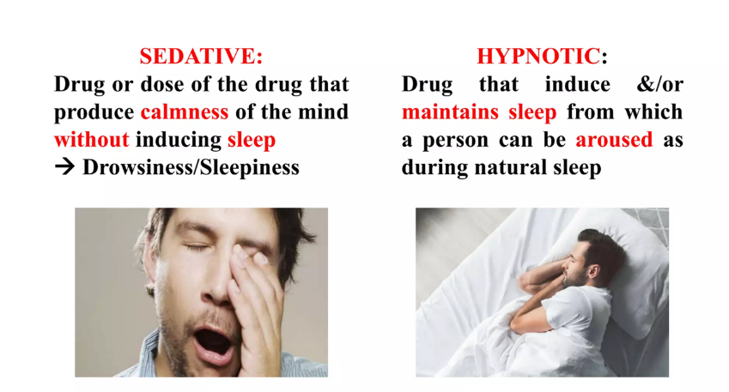
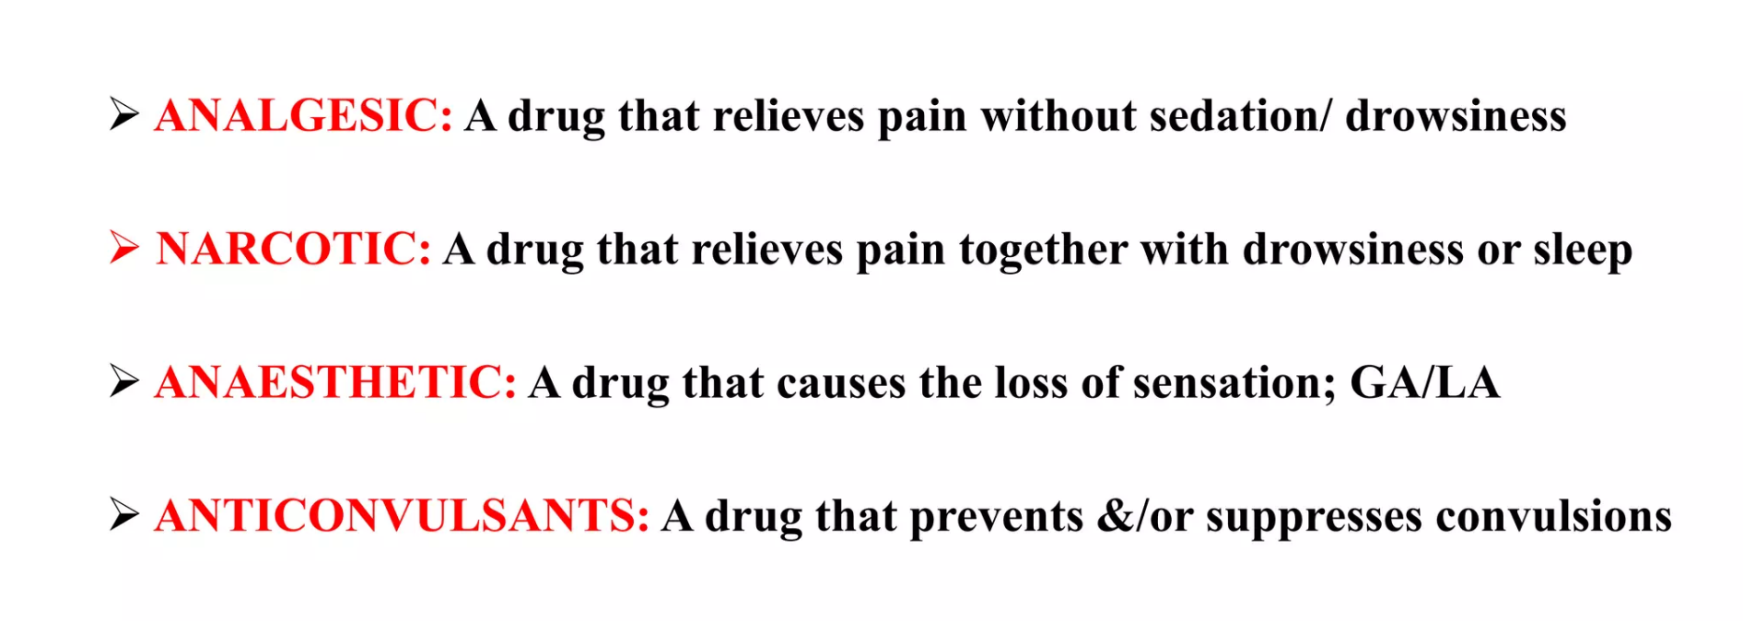
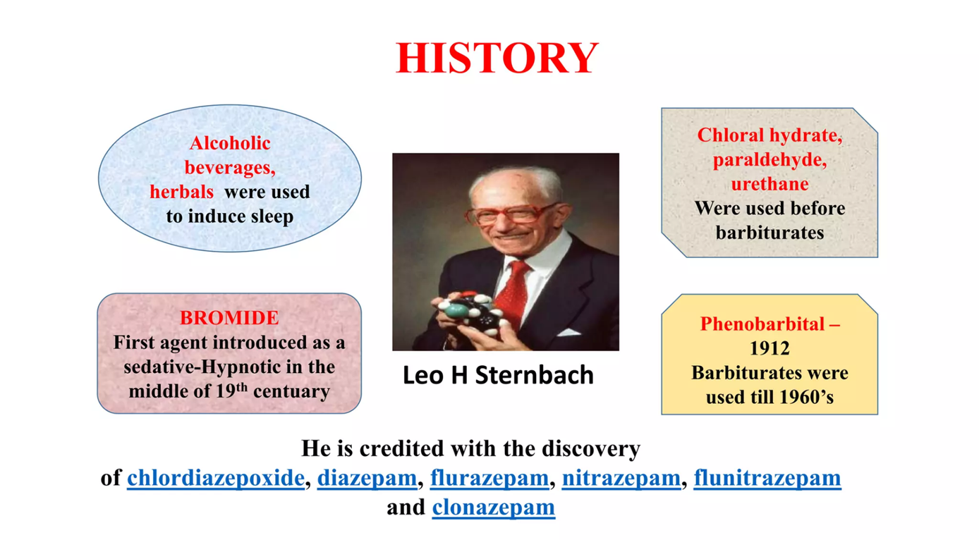

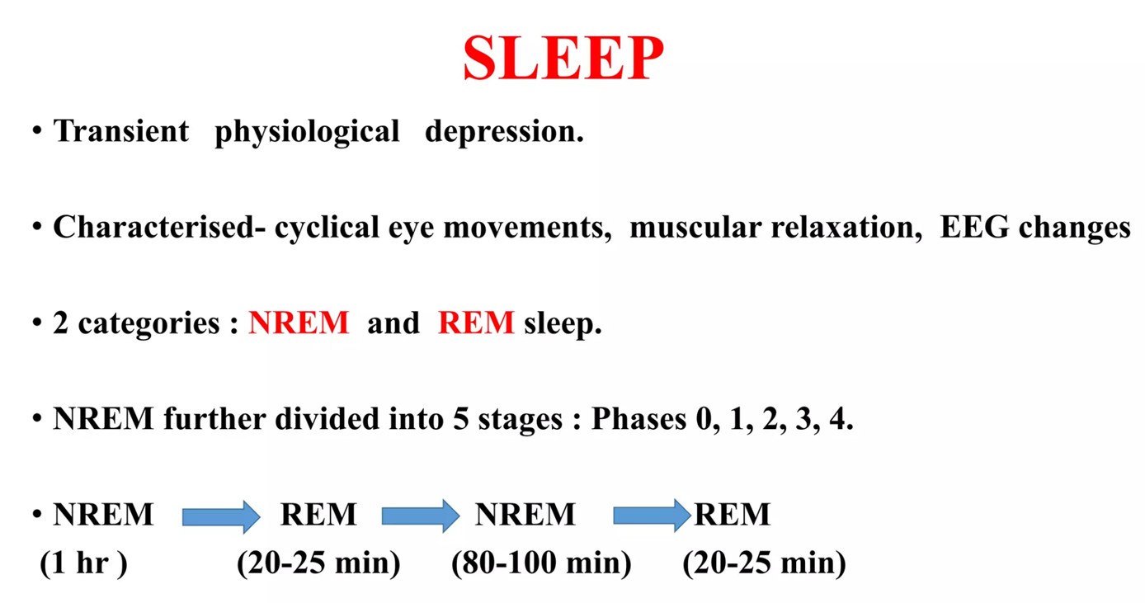

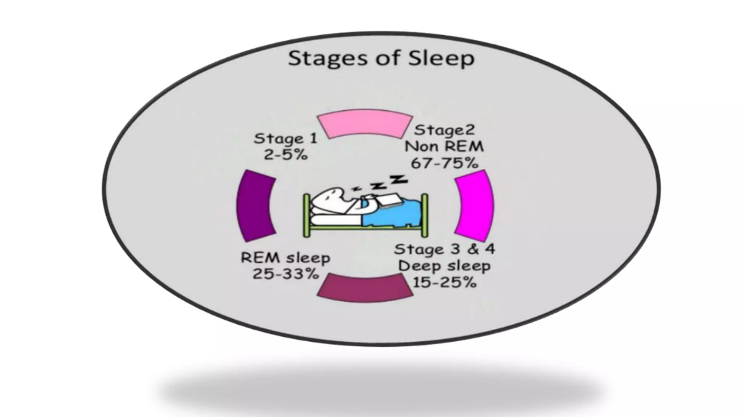

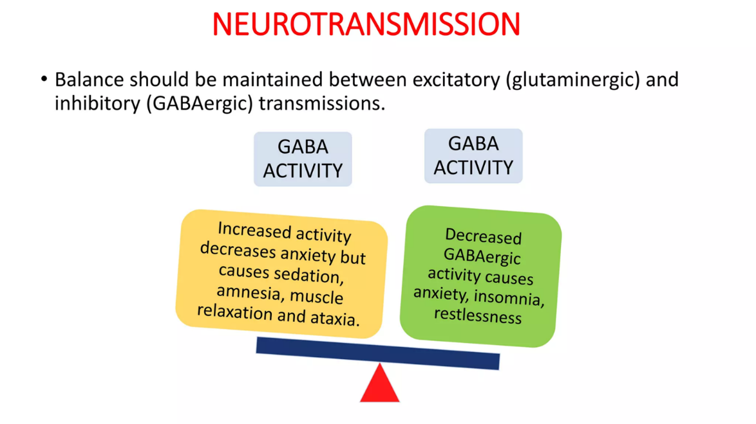

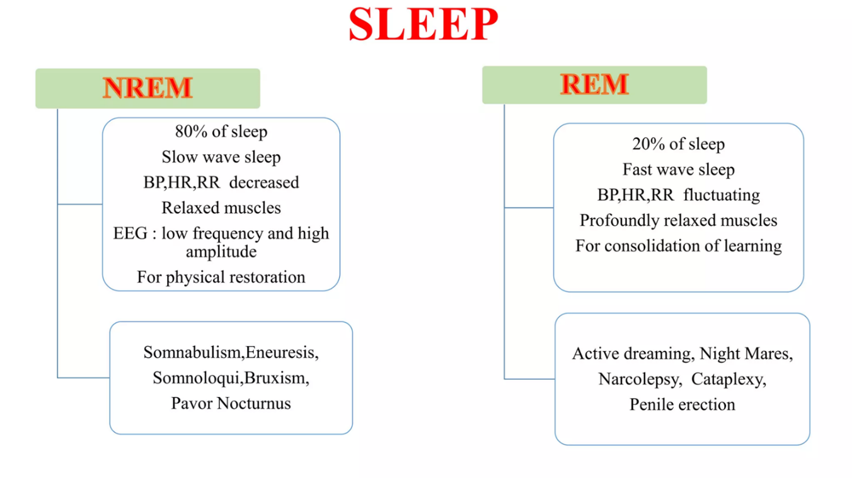

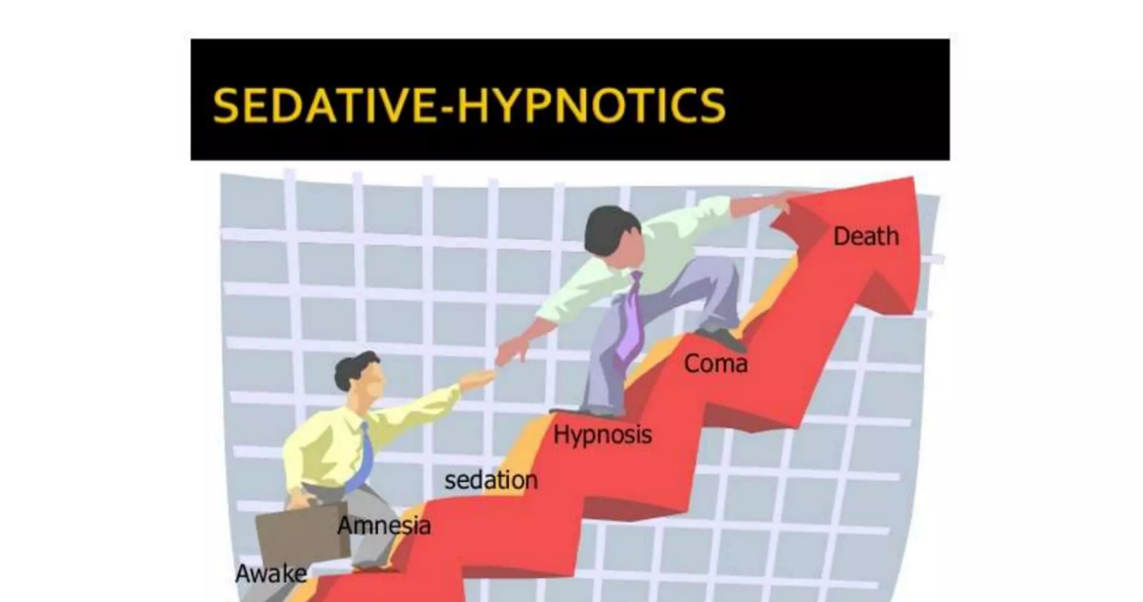

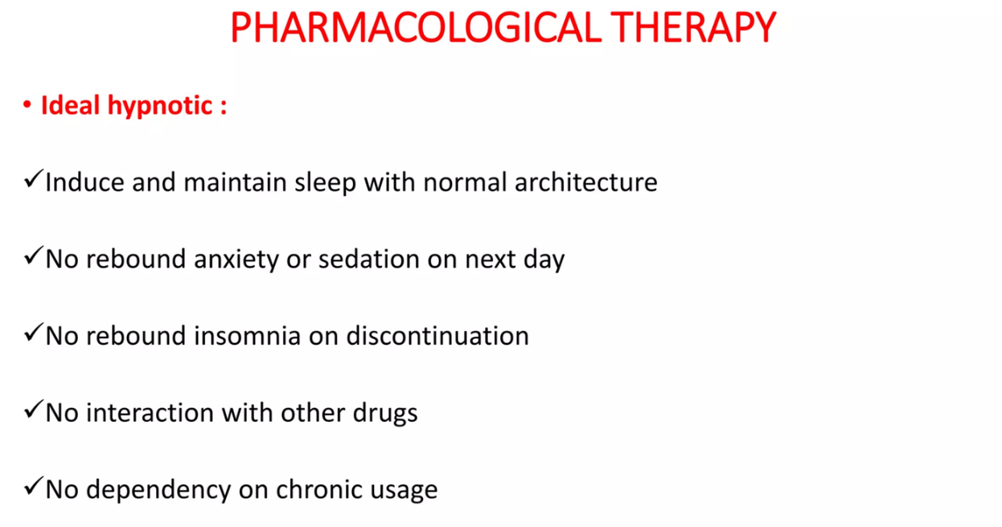

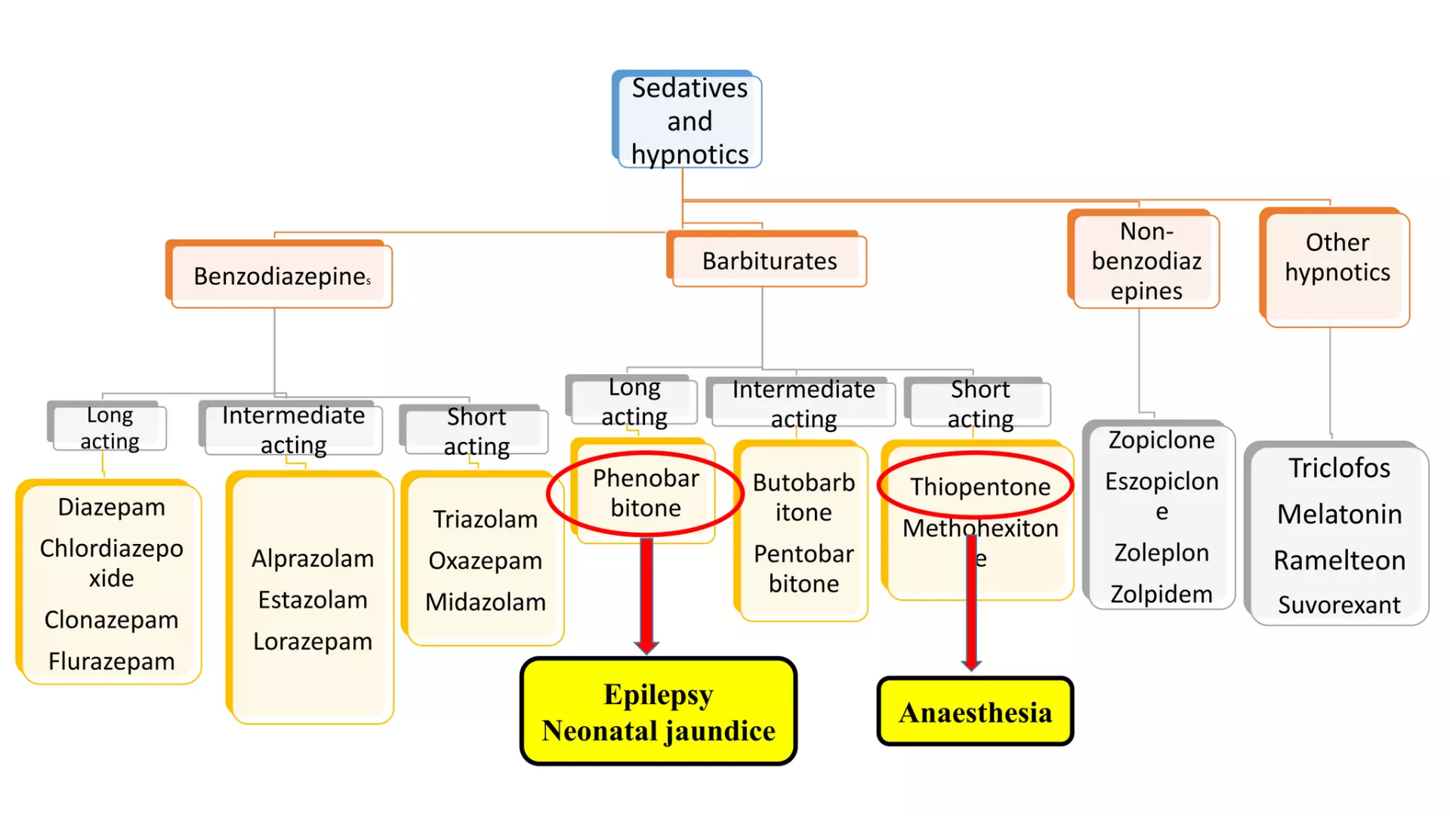

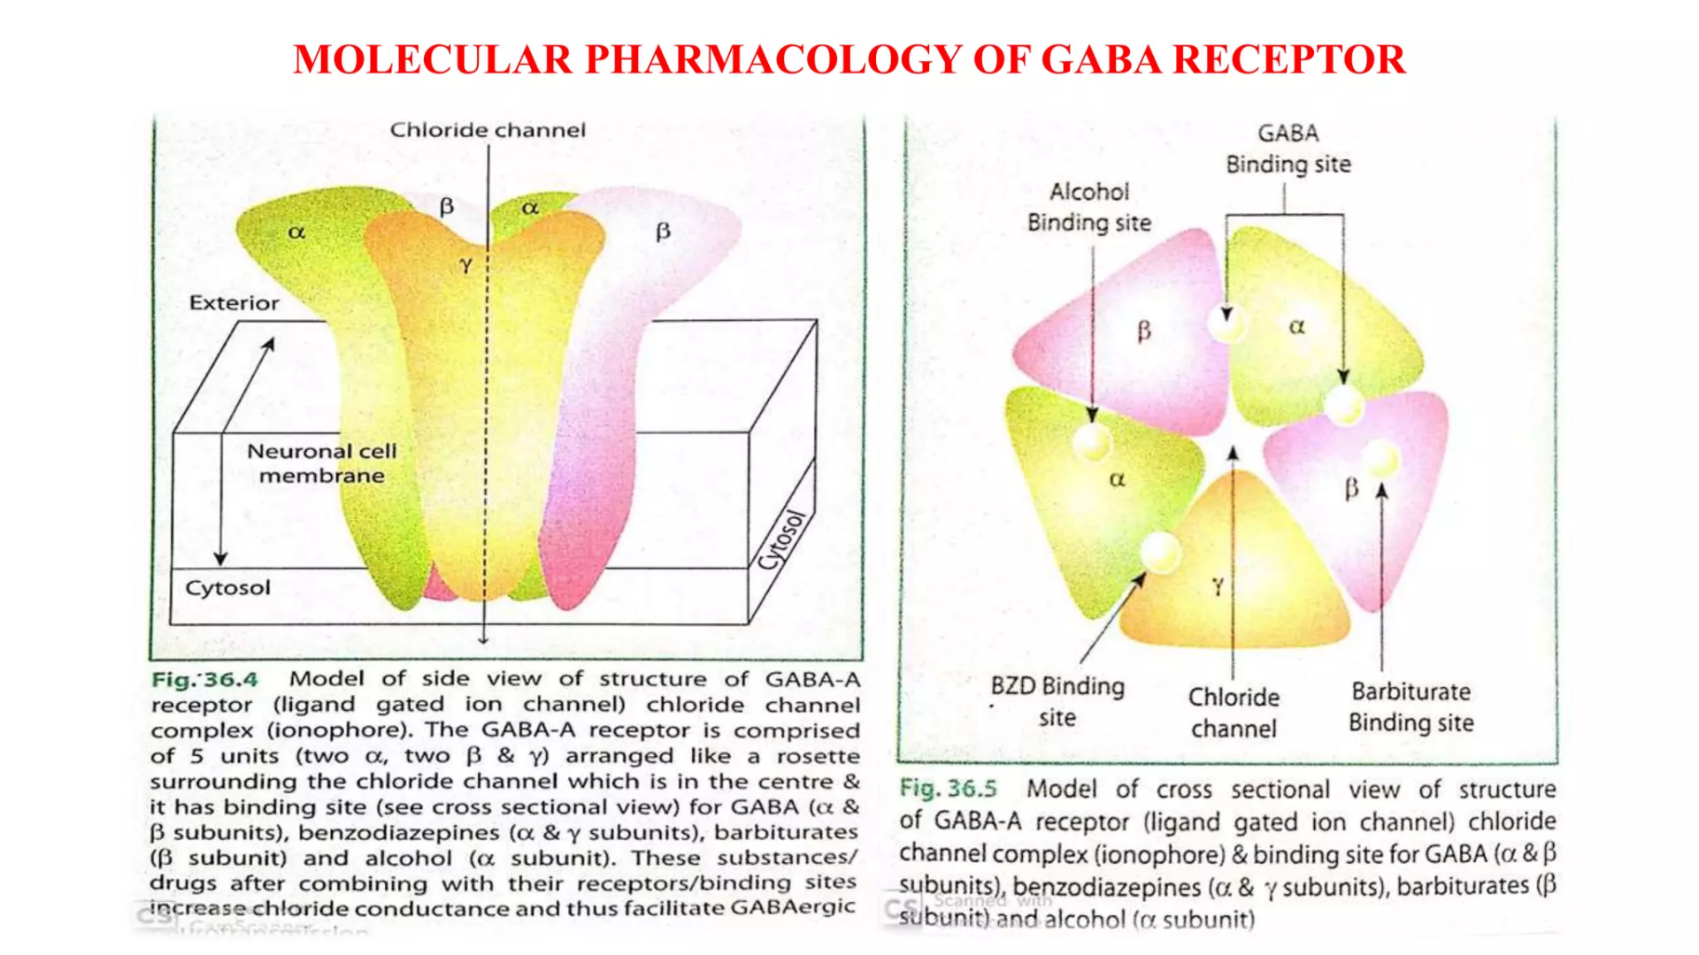

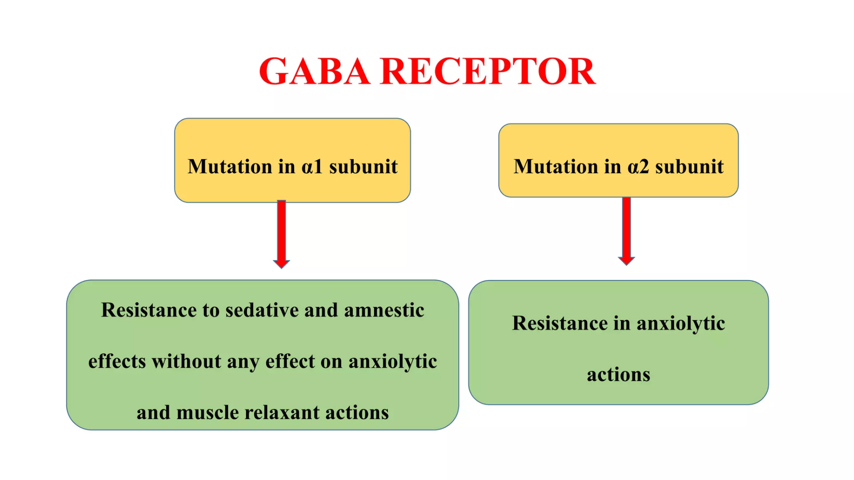

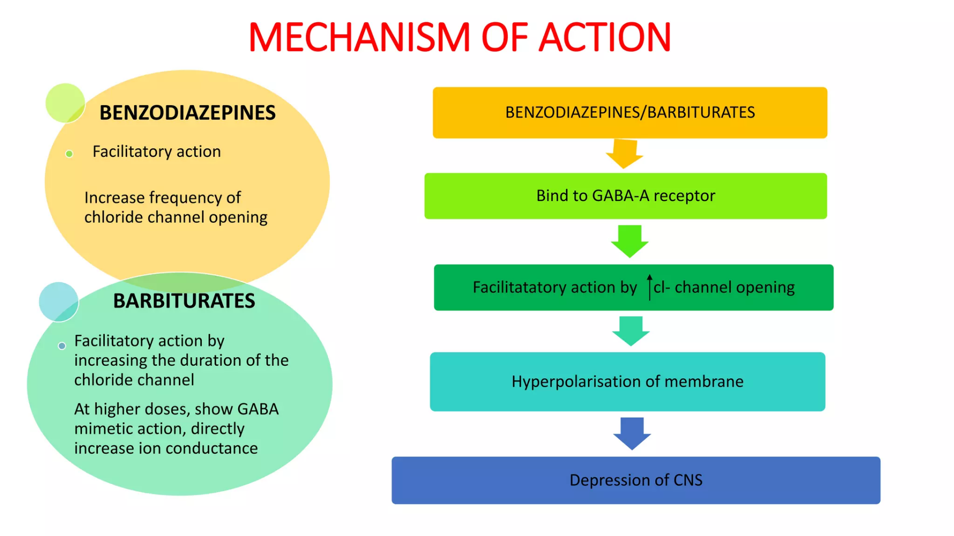
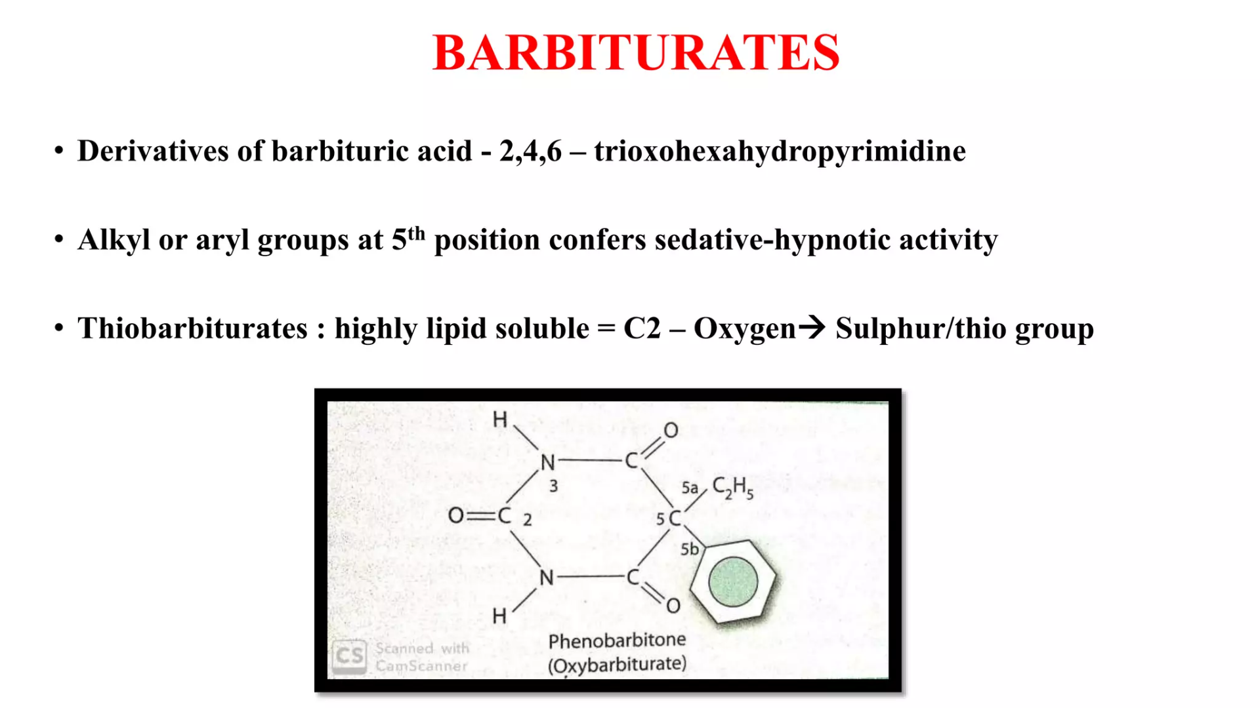

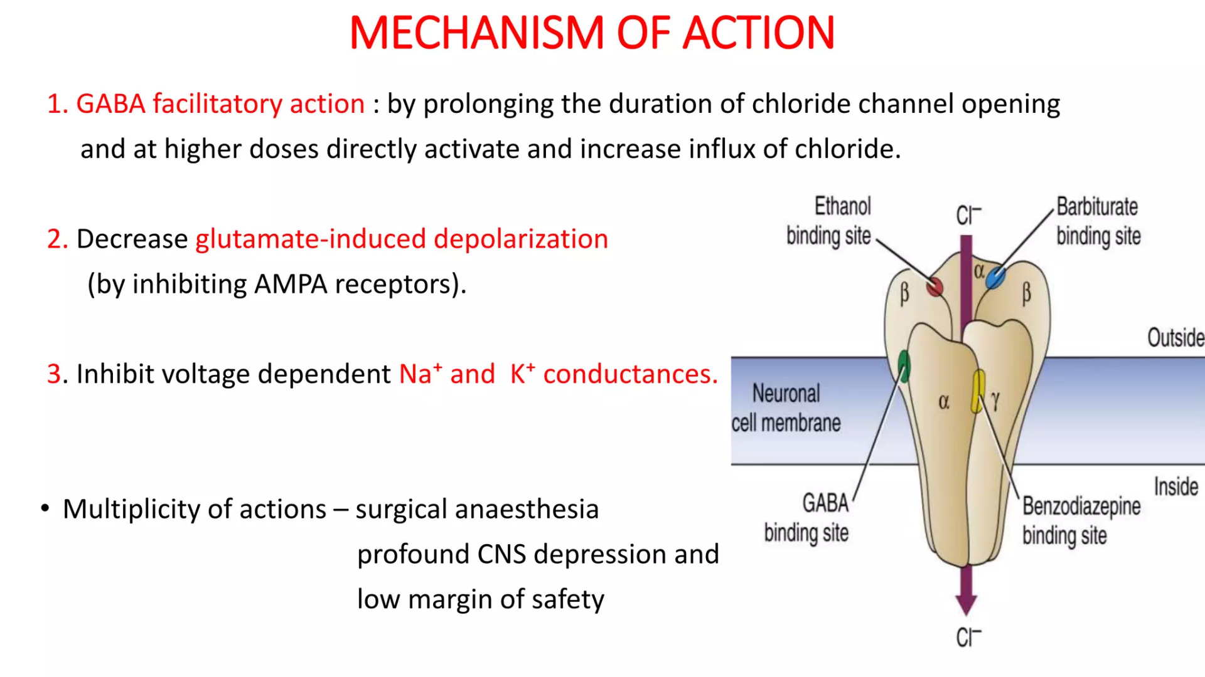

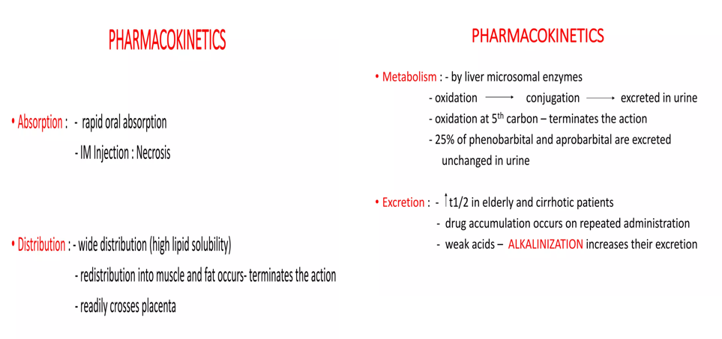

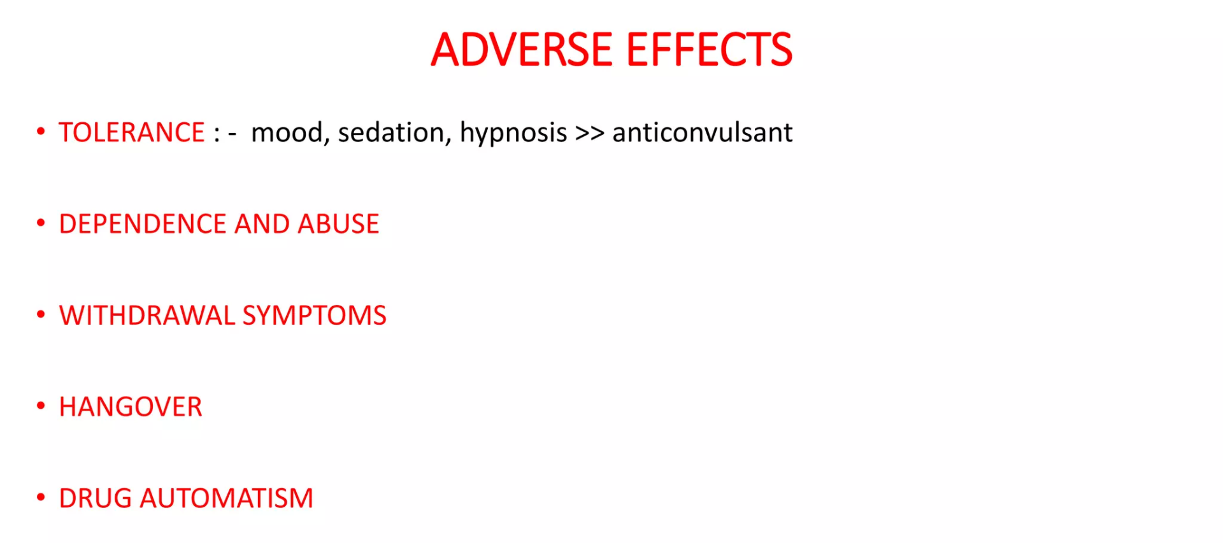

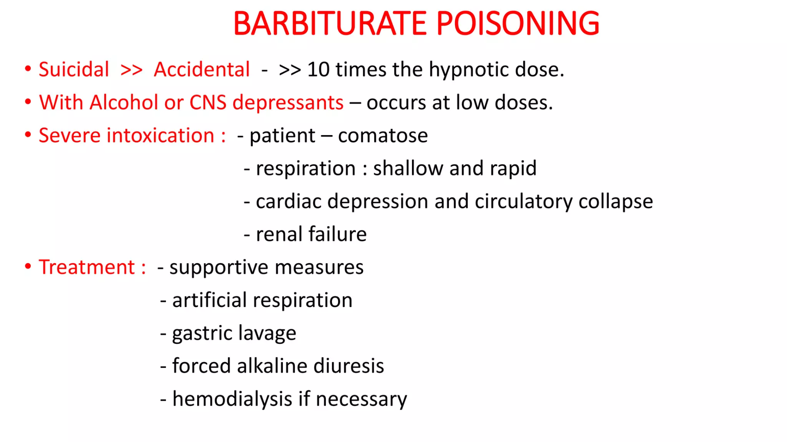

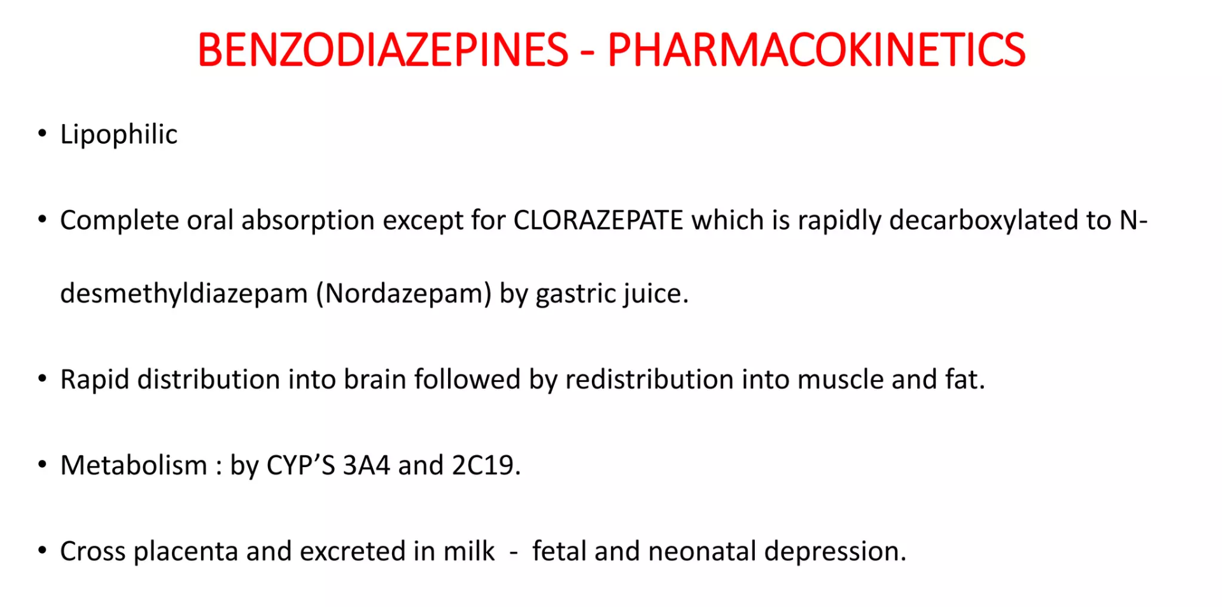
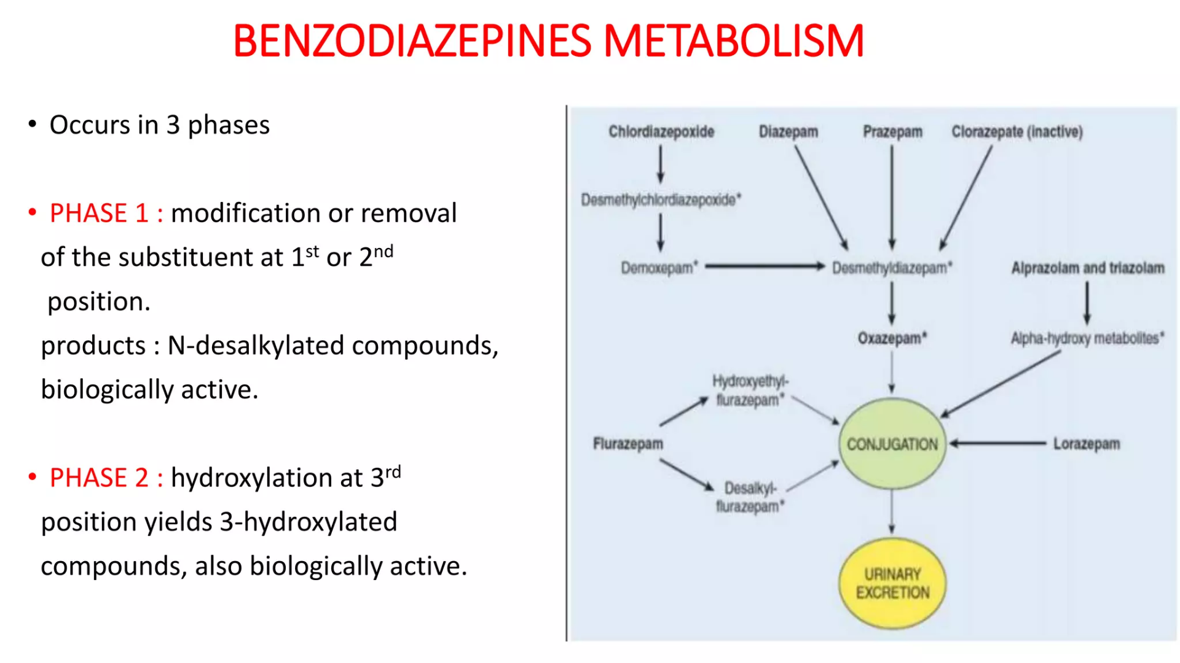
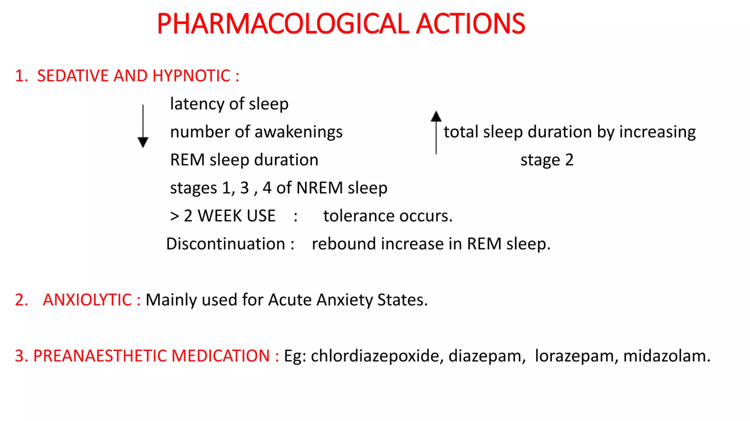
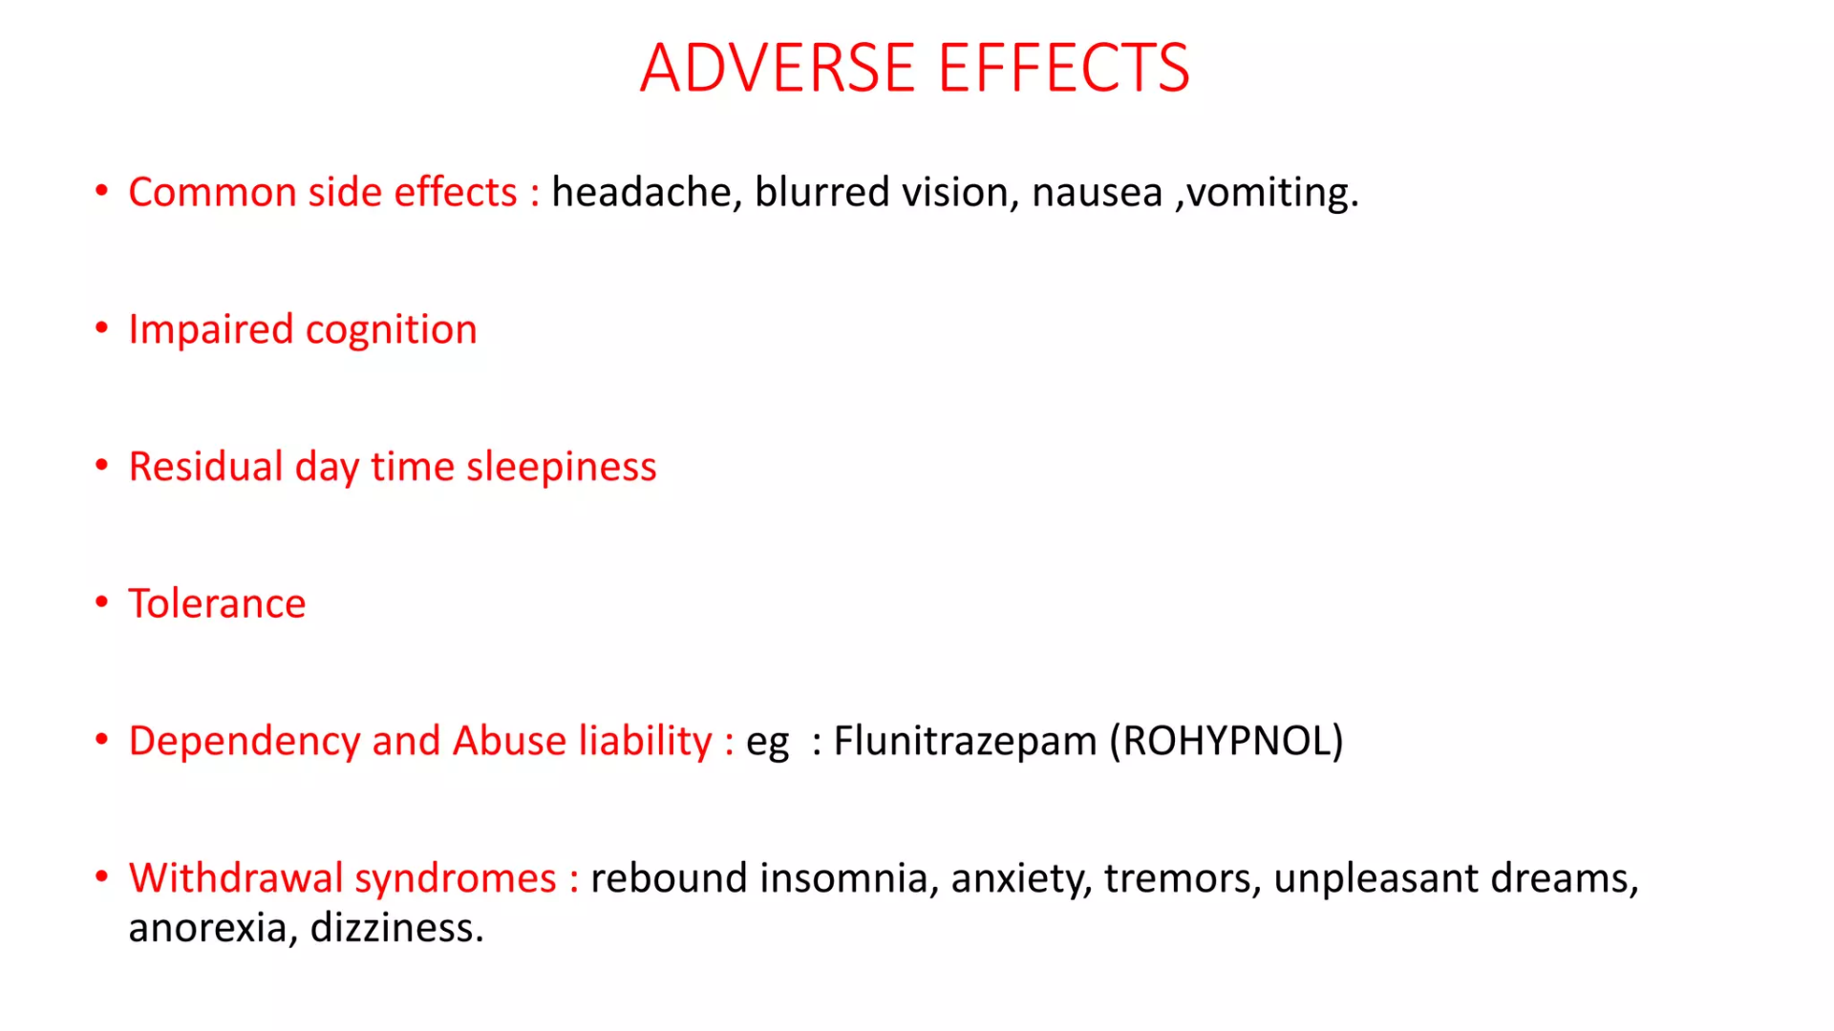
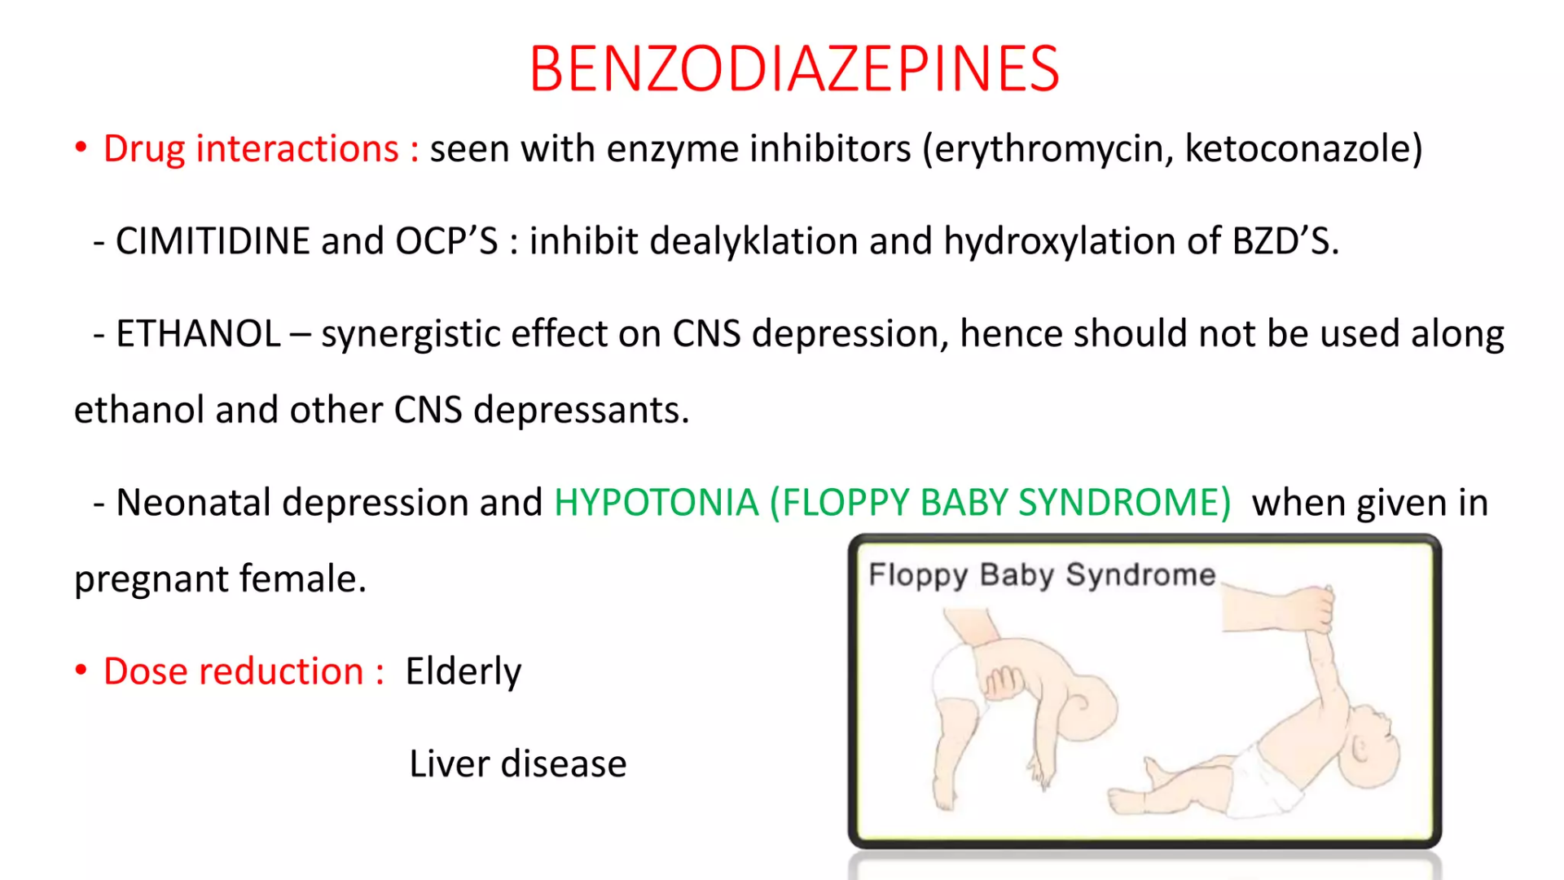
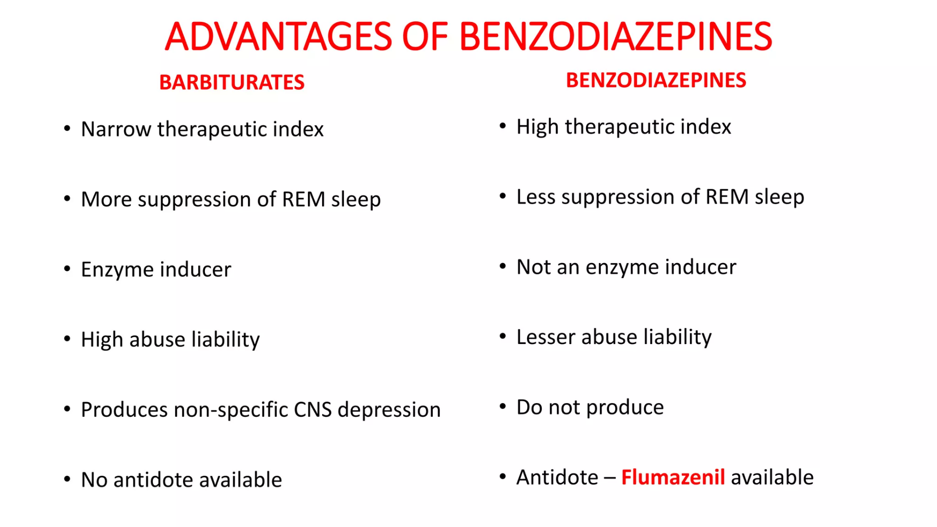

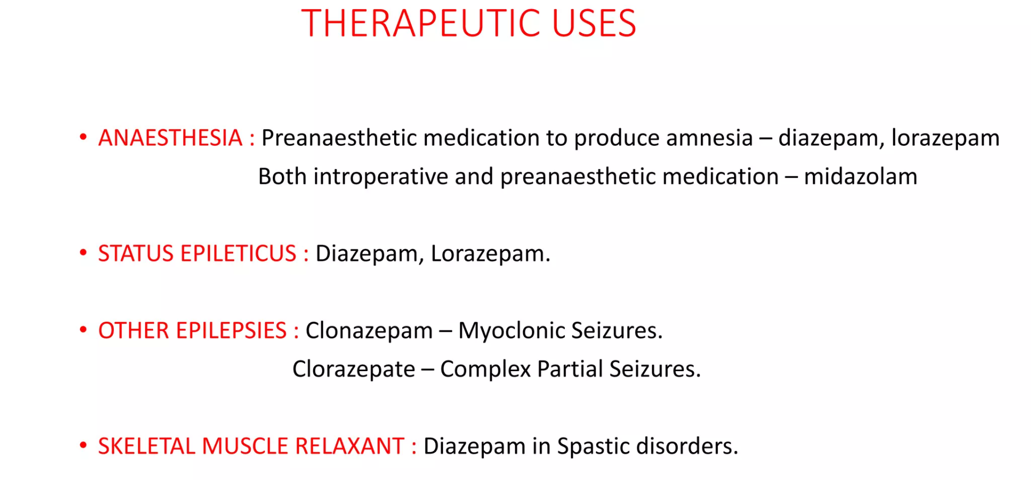
Alcohol is a CNS depressant that affects in a dose dependent fashion, producing sedation, that progress to sleep, unconsciousness, coma, respiratory failure eading to vascular collapse.
Other forms of alcohols:
- Absolute alcohol - 99% w/w ethanol.
- Rectified spirit - 90% w/w ethanol.
- Proof spirit – 49.29% w/w ethanol.

Pharmacological actions
1.Local actions:
- ethanol is a mild rubefacient and counter irritant.
- Injected s.c causes intense pain and inflammation.
- Injected around nerve it produces permanent damage.
- Alcohol is an astringent.
- By precipitating bacterial proteins it acts as an antiseptic.
- this effect is predominant at 70-90% alcohol.

2.Effect on CNS:
It is a neuronal depressant.
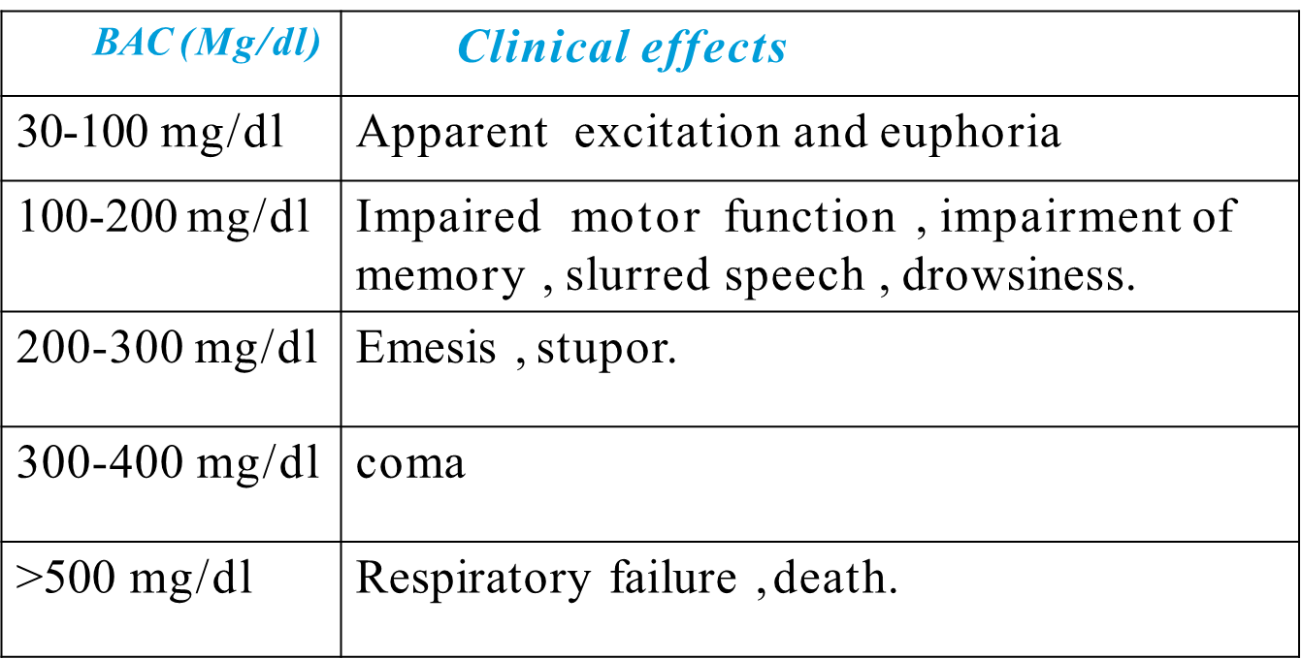

Mechanism of action
- It promotes GABAA Receptor mediated synaptic inhibition (through chloride channel opening)
- Inhibits NMDA and kainate type of excitatory amino acid receptor (operating through cation channels)
- Ethanol can indirectly reduce neuro transmitter release by inhibiting voltage sensitive neuronal channels.
3.On cvs:
- The effects are dose dependent.

- Small doses : produces cutaneous and gastric vasodilatation. Skin is warm and flushed.BP is not effected.
- Moderate doses :causes tachycardia , mild rise in BP.
- Large doses :cause direct myocardial as well as vasomotor depression and fall in BP.

4.On blood:
- Megaloblastic anaemia has been seen in chronic alcoholism due to foliate deficiency.

5.On body temperature:
- It produces a sense of warmth due to cutaneous and gastric vasodilatation.

6.Respiration:
- Alcoholic beverages acts as respiratory stimulant in collapse by irritating buccal and pharyngeal mucosa.

7.GIT:
- Higher conc. (>20%) inhibit gastric secretions, cause vomiting, mucosal congestion and gastritis.
- LES tone is reduced by alcohol- bowel movement may be altered in either directions.

8.skeletal muscle:
- Fatigue is allayed by small doses.
- Weakness and myopathy occurs in chronic alcoholism.
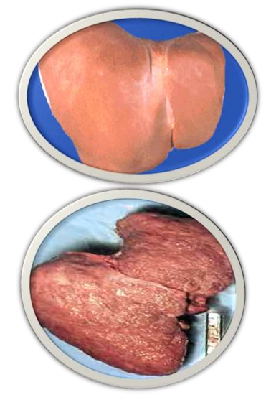
9.liver:
- Causes alcoholic liver cirrhosis
- By alcohol metabolism acetaldehyde gets accumulated and damages the function of liver.
- It induces inflammation and damage the hepatocytes.
- Regular intake induces microsomal enzymes present in liver.

10.Kidney:
- Diuresis is often noticed after alcohol intake
- Due to water ingested and alcohol induced inhibition of ADH secretion.

11.endocrine system:
- Alcohol increases adrenalin release which causes hyperglycemia.
- Acute intoxification is often associated with hypoglycemia and depletion of hepatic glycogen,because gluconeogenesis is inhibited ,glucose must be given.

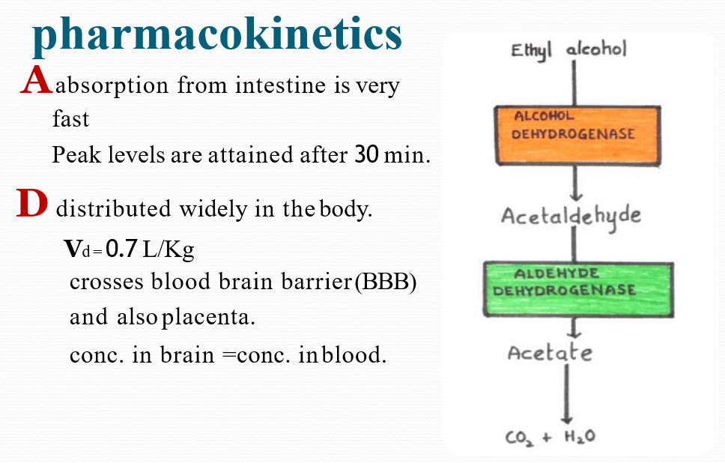

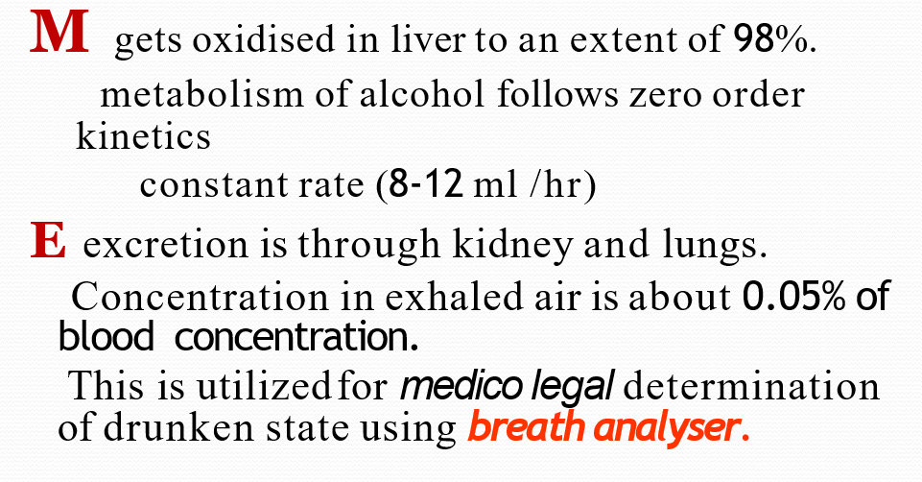
Contra indications:
- Peptic ulcer , hyper acidity.
- Epileptics : seizures may
- precipitated.
- Severe liver disease patients.
- Pregnant women :
even moderate drinking cause foetal alcohol syndrome resulting in intrauterine
growth retardation, low IQ, facial and other abnormalities.

ADVERSE EFFECTS:
- Moderate drinking –nausea , vomiting , flushing , hangover , traffic accidents.
- Acute alcoholic intoxication – hypotension ,gastritis , hypoglycemia , respiratory depression , coma , death.
TREATMENT:
- Gastric lavage
- Correction of hypoglycaemia by glucose infusion. (thiamine 100 mg in 500 ml glucose solution)
- Chronic alcoholism -
- Physical dependence occurs
- Impaired mental and physical performances
- Neurological problems are common – pellagra, tremors, seizures, psychosis…
- Alcoholic liver cirrhosis, hypertension, cardiomyopathy, stroke, acute pancreatitis, infertility and skeletal myopathy.

- Withdrawal syndrome
- Anxiety ,sweating , tremor , impairment of sleep , confusion , hallucination , convulsions..
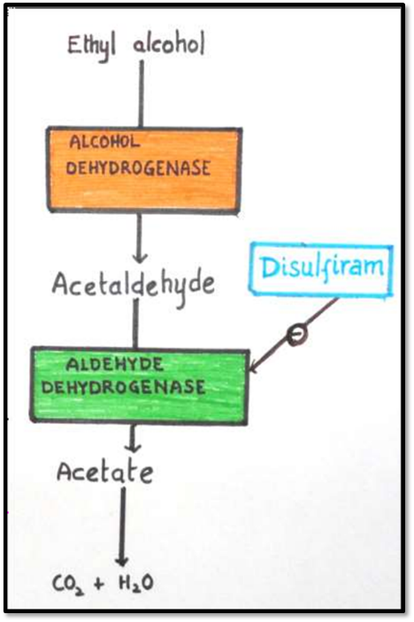
TREATMENT
- Benzodiazepines (chordiazepoxide , diazepam)
- Naltrexone – opioid receptor antagonist.
- Acamprostate – weak NMDA receptor antagonist.
- Ondansetron – 5-HT3 antagonist.
- Topiramate – anti-epileptic.

Aldehyde dehydrogenase inhibitors
Disulfiram
It inhibits enzyme aldehyde
dehydrogenase
Symptoms:
Flushing , burning sensation , throbbing headache , perspiration,uneasiness,tightness in chest, dizziness,vomiting,mental confusion.
Duration(1-4 hrs).
Disulfiram has been used in chronic alcoholics who are motivated and sincerely desire to leave the habit.

Side effects:
- Rashes
- Metallic taste
- Nervousness
- Abdominal upset
Drugs:
ESPERAL – 250mg
ANTADICT -250mg

CLINICAL USES:
- As antiseptic
- Rubefacient and counter irritant for sprains , joint pains.
- As appetite stimulant and carminative: 30-50ml of 7-10% alcohol may be taken as beverages and tinctures.
- To treat methanol poisoning

Guidelines for safe drinking
- On an average 1-2 drinks per day is usually safe.
- Do not drive or engage in hazardous activities after drinking.
- Do not drink if any interacting drug has been taken.

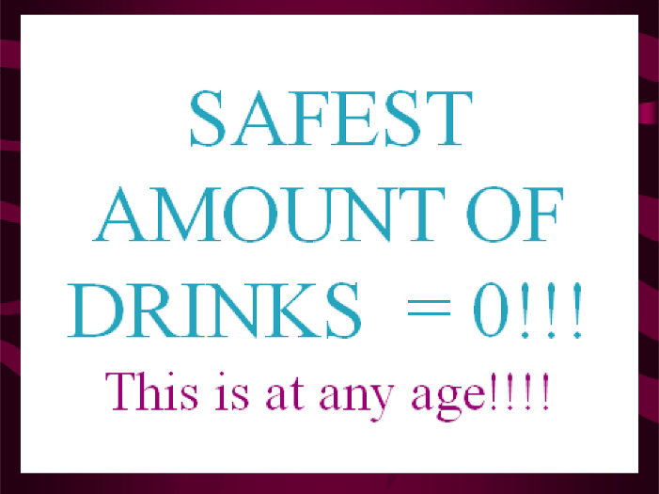
METHYL ALCOHOL
- Methanol is also a CNS depressant as ethanol.
- Even 15 ml of methanol causes blindness
- 30 ml causes death
- 75-100 ml is regarded as fatal dose.
- Manifestations of methanol poisoning
- Vomiting , headache , epigastric pain , uneasiness , bradycardia , hypotension
- Methanol is metabolised to formaldehyde and formic acid.
- The specific toxicity of formic acid is retinal damage.
TREATMENT:
- Gastric lavage with sod.bicarbonate.
- Pot.chloride infusion.
- Haemodialysis.
- Fomepizole –is a specific inhibitor of alcohol dehydrogenase.

